DevOps Assessment (Faizan)

1. Visit <https://github.com/onecommons/unfurl>

Done

1. Press “star” at the upper right  (very important! :)

Done ☺

1. Follow the directions to Install Unfurl (Linux or Mac only -- on Windows use the WSL2 subsystem)

Done with below steps:

System OS: mac

Python version: 3.9.10

Pip3 version: 22.0.3

**Step 1:** Install unfurl using pip3 on mac

Pip3 install unfurl

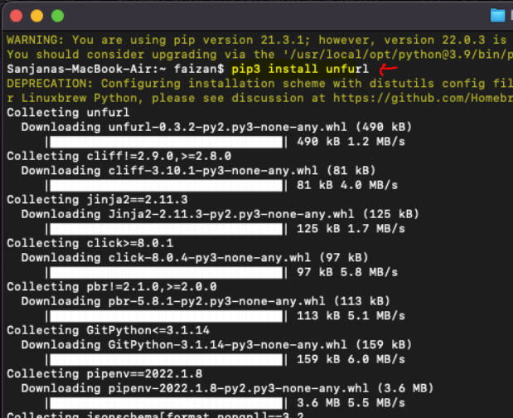

**Installation completed.**

1. Create a new unfurl project (for example see <https://docs.unfurl.run/quickstart.html>)

Created a new project:

Project_name: unfurl_home

**Step 1: initialize home project**

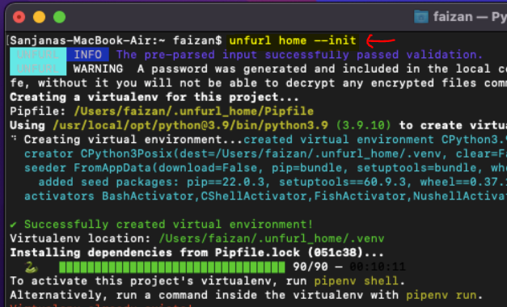

**Step 2:** Create own project called unfurl_hello

**Command:** unfurl init –create-environment unfurl_hello

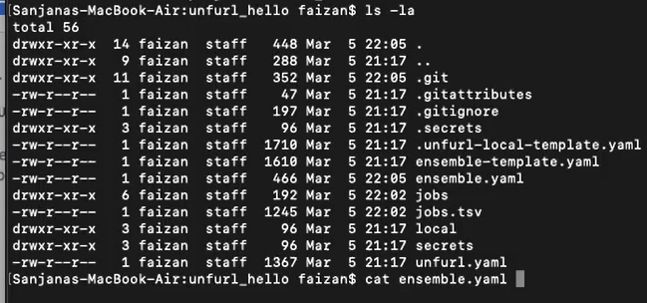

1. Edit the YAML in ensemble-template.yaml to a simple “hello world” node template using  a DevOps tool such as Terraform, Ansible or just a shell script. This template doesn’t need to actually do anything significant, see  <https://docs.unfurl.run/configurators.html> for some simple examples.

Created ensemble.yaml file:

Used shell example to create a simple shell based ensemble to echo “Hello World”.

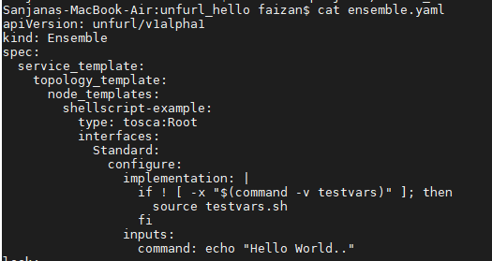

1. Deploy your ensemble using “unfurl deploy”

Deployed and hello world message was displayed

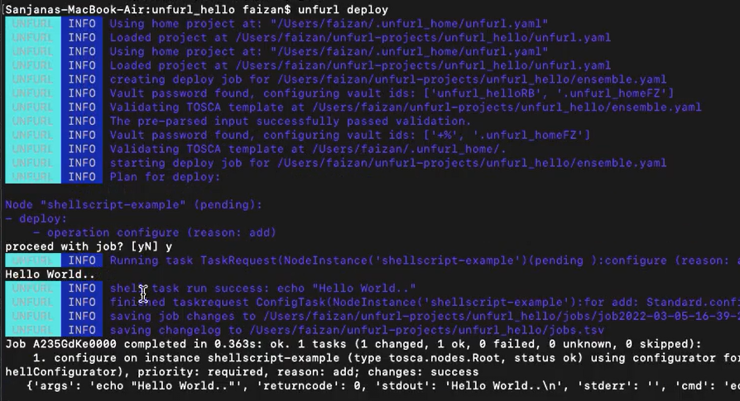

1. Push the repository created by Unfurl your github or gitlab account. (Note: if you push to gitlab it will automatically create a private project for you.)

Pushed the local repository to github.

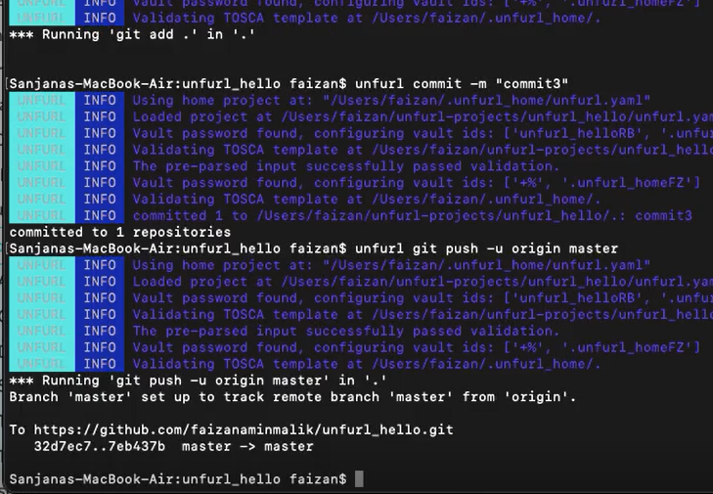

1. Create a short (2 or 3 minutes) video describing the ensemble you created and any challenges you faced building it. This is unreleased software and so it is buggy and poorly documented -- so don’t be shy with your feedback!

Video is created and uploaded to github repository mentioned below.

**Challenges faced:**

1. **Incompatible version of markupsafe got installed.**

With a standard procedure to install unfurl using pip3 install unfurl, it installed markupsafe version 2.1.0, which resulted in some issues.

**Error**:

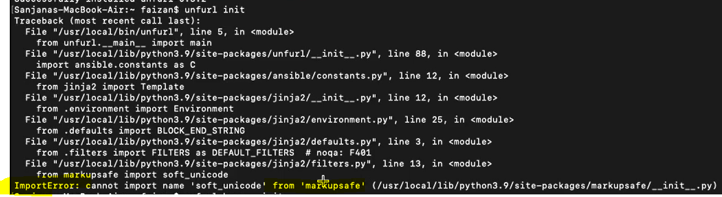

**Fix**: Install and reinstallmarkupsafe version 2.0.1

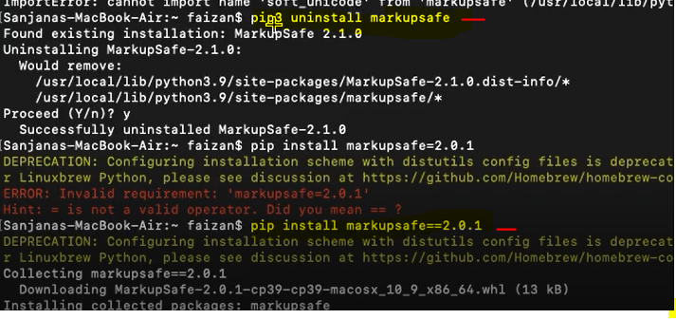

Markupsafe reinstallation was done for both base machine as well as venv.

1. Share the video and repository you created on github or gitlab

Github repository: https://github.com/faizanaminmalik/unfurl_hello